SpendWise
A Simple Backend Learning Project
Ideation Phase · Brainstorm & Idea Prioritization

Date | 08 March 2026
Project Name | SpendWise
Document Type | Ideation Phase — Brainstorm & Idea Prioritization
Team ID | SWTID-2026-1005

Overview
Brainstorming creates an open environment where team members can freely share ideas to solve a problem. For SpendWise, the goal is to generate simple, practical ideas that help students learn backend development. All ideas are first listed without judgement, then grouped by theme, and finally prioritized based on usefulness and feasibility for beginners.

1 | Team Gathering & Problem Statement  Collaborate as a team and align on what you want to build.

Team Setup | Define the Problem | Tool Check
Decide participants: Backend students and their mentor. | Clarify scope: Examples should neither be too complex nor too basic. | Prepare tools: Postman, Miro, or a shared Whiteboard.

Problem Statement
Beginner students find it hard to learn backend because most projects are either too simple or too complex.
SpendWise bridges this gap by building a focused, real-world expense tracking API.

TIP
Share simple ideas freely — no judgement at this stage.
Think about CRUD operations and JWT as core learning pillars.
Group similar items together once all ideas are on the table.
Pick the best ideas by weighing both value and feasibility.

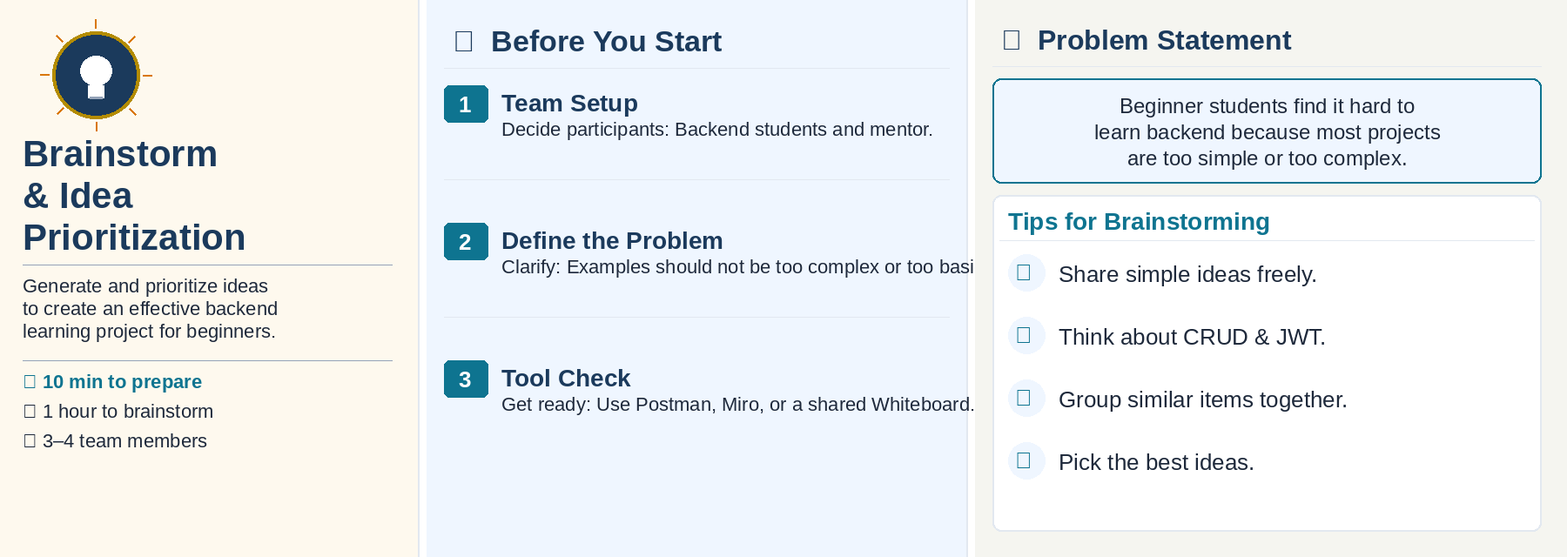

2 | Brainstorm & Idea Listing  Write down any ideas that come to mind to support the backend learning project.

# | Contributor | Idea
Person 1 | LOGESH S | Implement Register & Login with JWT Authentication.
Person 2 | YUVARAJ M | CRUD API for adding, viewing, updating, and deleting user expenses.
Person 3 | THARUNESH R | Use MongoDB with Mongoose to store users and expenses.
Person 4 | BHARATH KUMAR M | Simple and clear folder structure with routes, controllers, and models.

TIP
Think about what concepts you struggled to understand when starting backend.
Share ideas that keep the project simple, focused, and easy to learn.
Every idea counts — filter and refine in the next step.

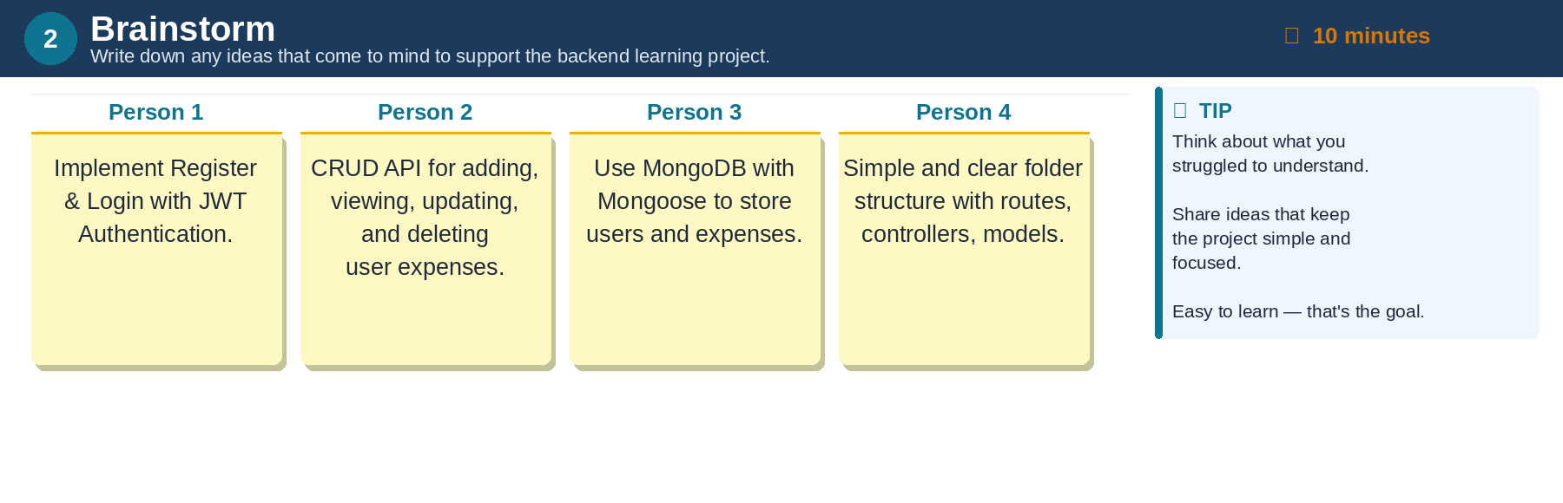

3 | Group Ideas by Theme  Take turns sharing ideas and group similar sticky notes into useful themes.

Theme / Category | Ideas Under This Theme
JWT & Authentication | • Build backend with Register & Login using JWT.  • Protect APIs with JWT middleware.  • Generate and verify JWT tokens.
CRUD Operations | • Add APIs to Create, Read, Update, Delete user data.  • Use a simple folder structure: models, routes, controllers.  • Ensure proper error messages for all endpoints.
MongoDB Integration | • Use MongoDB for storing users and expense records.  • Connect to MongoDB using Mongoose ODM.  • Provide a Postman collection for easy testing.

TIP
Add tags to ideas to find, organise, and categorise them easily.
Key tags to consider: CRUD Operations · JWT & Authentication · MongoDB Integration.
Give each group a clear, descriptive label once all ideas are clustered.

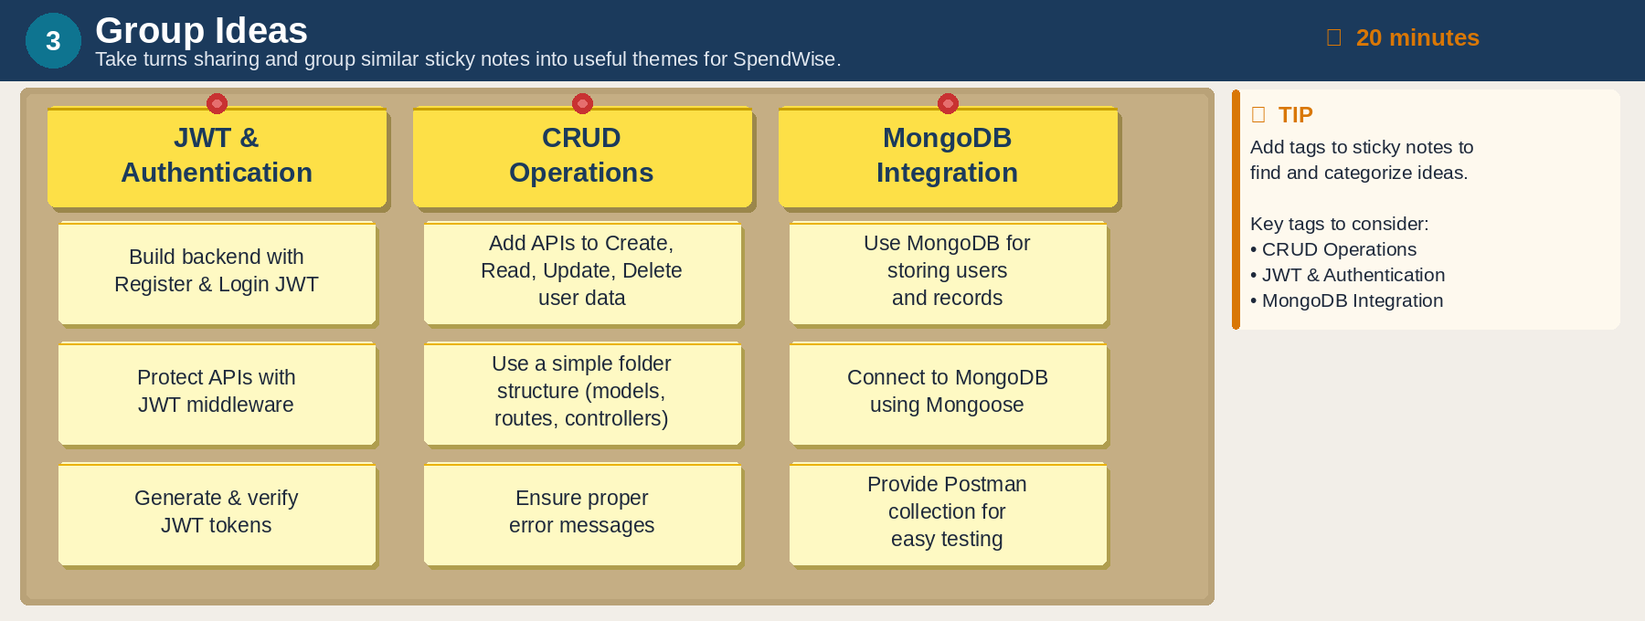

4 | Idea Prioritization  Align as a team to prioritize SpendWise ideas based on importance and feasibility.

Quadrant | What to Do With These Ideas
High Importance + High Feasibility | Prioritize — implement in the core project.
High Importance + Low Feasibility | Plan carefully — include if time permits.
Low Importance + High Feasibility | Nice-to-have — add as optional bonus features.
Low Importance + Low Feasibility | Defer or drop — not worth the effort now.

Feature Priority Summary
Feature | Priority | Rationale
CRUD Operations | High | Core skill — must implement.
MongoDB Integration | High | Required for data persistence.
Portfolio Tracker | Medium | Good for structured practice.
JWT Authentication | Medium | Important but more complex.
Postman Testing | Low | Nice-to-have bonus feature.

TIP
Place ideas that are critical to learn backend in the top-right quadrant (high importance & high feasibility).
Ideas that are nice-to-have but not crucial can sit in the bottom-right quadrant.
Any less important or less feasible ideas can be deferred or dropped.

